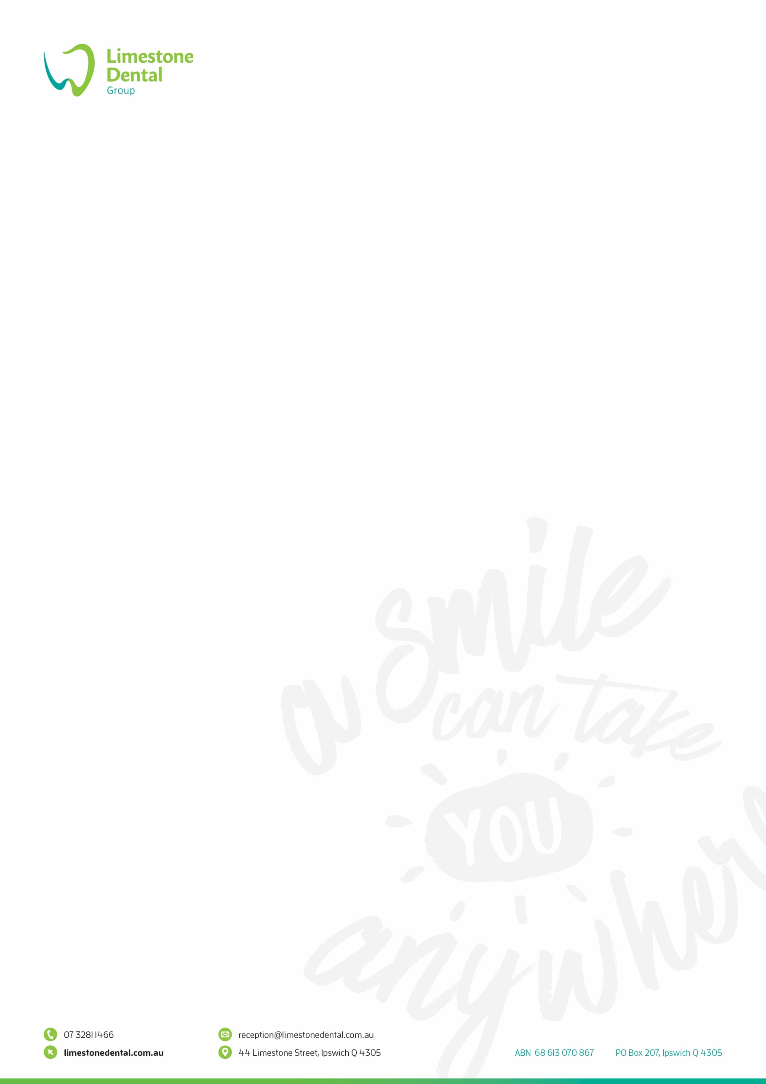

**DENTIST POSITION - LIMESTONE DENTAL**

**About the position**

* Full time or Part time position, negotiable working hours
* Attractive commission-based remuneration.
* May suite a dentist wanting a part-time position
* You will be required to work weekdays, Saturdays and some nights.
* Interest in restorative dentistry including crowns and implants.
* Career opportunity to purchase into the practice and become a shareholder.

**About you**

* Applicants must have excellent communication skills and be well presented.
* A commitment to excellence in dental clinic skills with a high degree of professionalism and enjoy working in a team environment.
* The successful candidate must demonstrate commitment to exemplary patient care and continuing self-education.
* Understanding and ability to comply with stringent infection control practice and procedures.
* Prepared to develop and grow your patient base.
* Applicants must be registered to practice in Australia, with an AHPRA registration, hold professional indemnity insurance and possess a Queensland radiation license.

**About our practice**

* Our practice is a well-established general dental practice, we pride ourselves on our patient care and reputation as a leading practice.
* We are located west of Brisbane and have an excellent reputation in the region.
* There are 10 surgeries that have been designed to create a relaxing environment for patients and a comfortable place for you to work.
* Our equipment is state of the art with computerised records and digital x-rays, an onsite dental lab with 2 dental technicians.
* You will be working with a friendly, strong and supportive team who are passionate about patient care.
* We have a team of over 20 fully trained permanent dental nurses.
* There are dedicated admin, reception and sterilising room staff to improve work productivity.
* We are passionate about training and regularly hold evenings to stay up-to-date on trends and changes.

To apply for the position or to ask further questions contact admin@limestonedental.com.au